

Matching (22 marks)

Place the LETTER beside the appropriate definition. Each term is used once and only once.

|  | **Term** | **Definition** | |
| --- | --- | --- | --- |
| **1** | All of a computer’s parts are wired, soldered or plugged into this. | a | ALU |
| **2** | Usually used for entertainment, this technology blocks out all other visuals, immersing the player in a whole other world. | b | ASCII |
| **3** | A base 2 number system where the only digits are 1s and 0s | c | Augmented Reality |
| **4** | Boolean variables hold either ___ or false | d | Binary |
| **5** | This type of memory does not change. It only holds start up instructions and similar information. | e | Byte |
| **6** | This acts as traffic cops, directing data flow across the bus. | f | Cache |
| **7** | The part of the CPU that does the math and if statement comparisons | g | Chip set |
| **8** | A chart of a logical operation’s inputs and outputs. | h | Control Unit |
| **9** | This type of software is used to do maintenance on the computer. Virus protection is one example. | i | Hard Drive |
| **10** | This type of scam involves using e-mails to trick people into revealing personal information like banking passwords. | j | Logic Gates |
| **11** | A temporary form of memory that stores open applications, files and other data. | k | Motherboard |
| **12** | Eight bits in size, it takes one of these units of memory to store a character such as a number or letter. | L | Operating System |
| **13** | The microscopic switches inside a computer | m | Phishing |
| **14** | A small number of transistors can be put together to make one of these. | n | RAM |
| **15** | Fast, very small, temporary storage that sits on and by the CPU. There are 2 levels of this type of memory. | o | Ransomware |
| **16** | This part of the CPU decides what the ALU is supposed to do. | p | Registers |
| **17** | The smallest memory cells, attached to the CPU. They contain data such as an address that the CPU needs next. | q | ROM/BIOS |
| **18** | The standard language that represents each character (letters, numbers and symbols) as a number from 0 to 255. | r | Transistors |
| **19** | With entertainment, training and other uses, this technology layers computer generated visuals over top of the real world. | w | True |
| **20** | A series of disks that can be used for long term storage of programs and data. | t | Truth table |
| **21** | Android and IOS are Smart Phone examples of this type of software. | u | Utilities |
| **22** | This type of malware will lock or encrypt the files on your computer until you send the creator money. | v | Virtual reality |

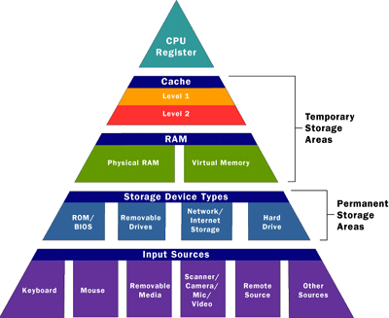

Multiple Choice and Short Answer

For next 2 questions, use the Memory Pyramid as your guide.

1) There is one important device that best fits in the empty space in the Memory Pyramid under Storage Device Types. What key device is missing?

2) Based on the Memory Pyramid, which of the following categories would a USB Memory Stick best fit into?

* 1. CPU Register
  2. Cache
  3. RAM
  4. Storage Device Types

3) The cheapest and easiest way to improve your computer’s overall performance would be to make an upgrade in which category?

* 1. CPU Register
  2. Cache
  3. RAM
  4. ROM

4) What are the 3 main parts of the CPU? (3 marks)

5) A byte is _________ bits (how many). Explain one of the ways this particular number of bits is important in computing or programming? (2 marks)

6) Registers can hold one of two things __________________ or ________________________.

Buying a Computer (7 marks)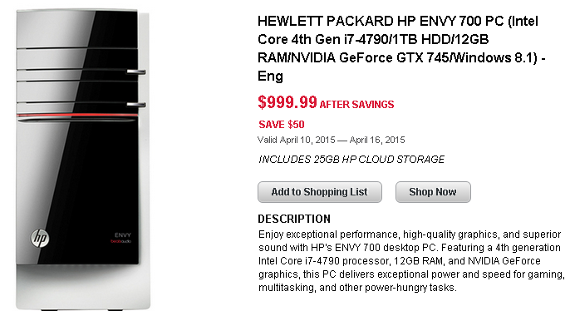

The following advertisement appeared in a Best Buy flyer in April a few years ago. This computer, while not top of the line, was quite powerful for its time.

Fill in the table of parts.

| Size of hard drive (include the units): |
| --- |
| Size of Main Memory (include the units): |
| Brand of Processor: |
| Type of Operating System |
| The processor’s speed is not obvious from the advertisement. If it was, what unit of measurement would be used to describe the speed? |

.

b) Imagine you are considering buying this computer. Pick one of the ‘Parts of the Computer’ from this advertisement that you feel is the most important to consider when buying a computer. Explain why it is important to your choice of computers by using examples in your own computing experience such as playing games, watching videos, etc.

| Part from ad: |
| --- |
| Why is the performance of this particular part important? In other words, what will this allow you to do that a weaker version would not? (1 mark for a general description) |

Emerging Tech

Read the article on the next two pages and then answer the questions below.

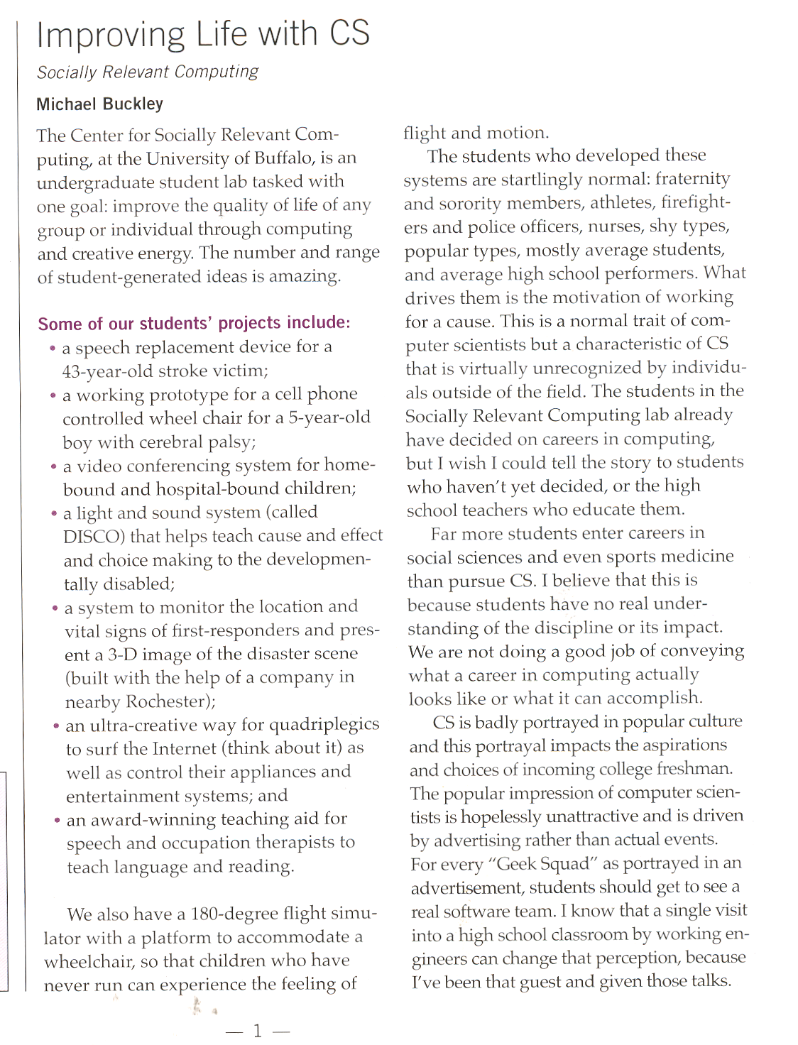

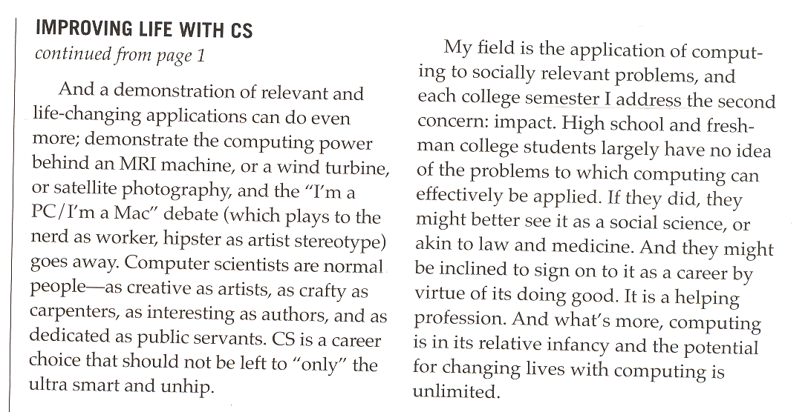

Imagine you have a younger sister in grade 9. You want to convince her to take Computer Science but she asks “isn’t that just for boys and nerds?” In a sentence, explain why the stereotype of a Computer Scientist is no longer valid OR explain why computer science is an important course to take. (1 mark)

We have talked about many technological innovations and this article describes some other real world applications of Computing Science. Choose one of the ideas or trends we have seen this year and ***explain in a paragraph*** why this idea caught your attention. This is worth 3 marks. If you can not think of something we discussed in class this year, you can use something from the article for a max of 2 marks. Your paragraph must do the following: (3 marks)

1. Explain the idea/innovation as if I have never heard about it before
2. Describe why this particular idea interested you
3. Explain who this innovation most greatly impacts and how. Be Specific. (use the next page if you run out of room)